Ghoshan Jagnathamani
Lab 1
ECEN 449 - 503

Introduction
In this Lab we set up Vivado and got familiarized with the ZYNQ 7000 FPGA board. Programming in Verilog to complete the tasks in 3 sections od the lab.

Procedure/Results
Lab1 a:
We set up the development project on Vivado to do a simple operation on the board’s LED light. The implementation was that the corresponding LED had to switch on when the button was pressed. We also added a constraints file to show how each input/output matches with the corresponding component in the board. The paired LED was switched on with the Switch.

Lab1 b:
In this part we had to implement a counter. The complicated part involved creating another module to divide the clock to 1Hz so that it will count every second. Also the count had to go up or down according to the input. The output was shown on the LEDs as a 4-bit counter. Initially I only transfromed the clock to 2Hz. And also the TA helped me with instantiating the module. Also the passed on new clock had to be a wire for it to work properly. And finally a synthesizable design was produced. This was the first project without much help.

Lab1 c:
This part was to replicate the jackpot game. Again a clock divider was needed similar to the one in part b to make the light changes visible. The lights had to shift in a one hot fashion and a case was employed to do this. If the corresponding button was pressed for the light, the winning condition was provoked. The result was that when a particular light switched on, if I was able to hit the switch fast enough, I was able to win the game. Or I could just keep a switch turned on and then when the light sequence came to that particular switch, after a clock period it would satisfy the winning condition. There were many ways to do this particular part, and I revised many time and found that this implementation was a simpler way to do it.

Verilog
1 a: switch.v
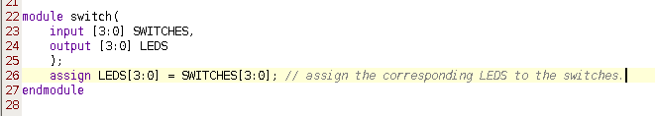

1 b: counter.v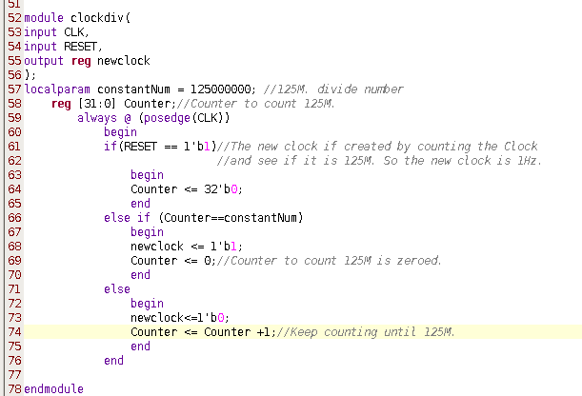r.v
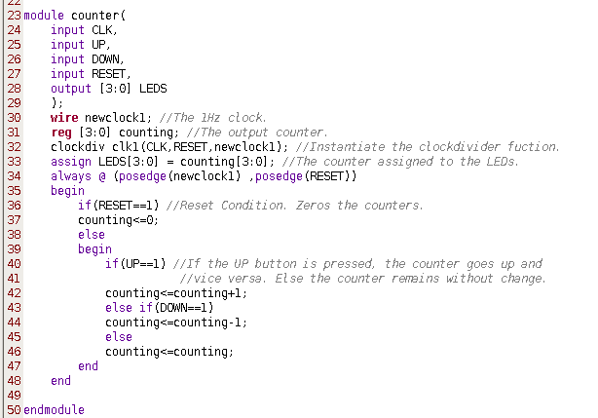

Conclusion
The new things learned in this lab are
- Vivado, development environment setting up
- FPGA board button, light, clock
- Verilog conditional statements.
- Bitstream synthesis and program to board
- Synthesizable code

Question
(a) How are the user push-buttons wired on the ZYBO board (i.e. what pins on the FPGA do each of them correspond to and are the signals pulled up or down)? You will have to consult the Master XDC file for this information.
The push buttons are located in the

##Buttons
#set_property -dict { PACKAGE_PIN R18 IOSTANDARD LVCMOS33 } [get_ports { btn[0] }]; #IO_L20N_T3_34 Sch=BTN0
#set_property -dict { PACKAGE_PIN P16 IOSTANDARD LVCMOS33 } [get_ports { btn[1] }]; #IO_L24N_T3_34 Sch=BTN1
#set_property -dict { PACKAGE_PIN V16 IOSTANDARD LVCMOS33 } [get_ports { btn[2] }]; #IO_L18P_T2_34 Sch=BTN2
#set_property -dict { PACKAGE_PIN Y16 IOSTANDARD LVCMOS33 } [get_ports { btn[3] }]; #IO_L7P_T1_34 Sch=BTN3

(b) What is the purpose of an edge detection circuit and how should it have been used in this lab?
The edge detection circuit detects any changes (transitions) in the signals provided in the sensitivity list. In this lab we use the edge detection to update the counter and LEDs. For example when the Clock changes, the counter increases and this change is detected by the edge detection circuit.

